**Where to open a steakhouse in Toronto?**

**Introduction**

In this project, the frequency of steakhouse restaurants in neighbourhoods of Toronto will be investigated. I’m trying to solve here a hypothetical problem of a steakhouse chain owner who has a lot of restaurants in US, in many states and cities and now wants to expand his business opening another restaurant in another country. As the closest country in North, he wants to start his business in Canada and Toronto seems to be the best city to open his first steakhouse restaurant as it is the capital. Nevertheless, he is worried that if he opens his restaurant in a neighbourhood where there are already a lot of steakhouses his restaurant would not be visited often and he cannot make profit. Therefore, my aim here is to list the frequency of steakhouses in every neighbourhood of Toronto to be able to give him an idea about where it would make sense to open a new steakhouse or not.

**Data**

What I need first is the list of neighborhoods in Toronto. Luckily there is a Wikipedia page where I can extract this information: <https://en.wikipedia.org/wiki/List_of_postal_codes_of_Canada:_M>. Once I have the list of neighbourhoods I will need location information for each neighbourhood, namely longitude and latitudes. This information is available online in <http://cocl.us/Geospatial_data>. When I have relevant location information for every neighborhood I can make a call to Foursquare and get the data regarding the venues in each neighbourhood. Afterwards, I dissect the venues according to their categories so that I can isolate steakhouses and create a list of neighborhoods with their steakhouse frequencies.

**Methods**

The data with the list of boroughs and neighborhoods in Toronto was obtained using BeautifulSoup library in Python and stored in a dataframe.

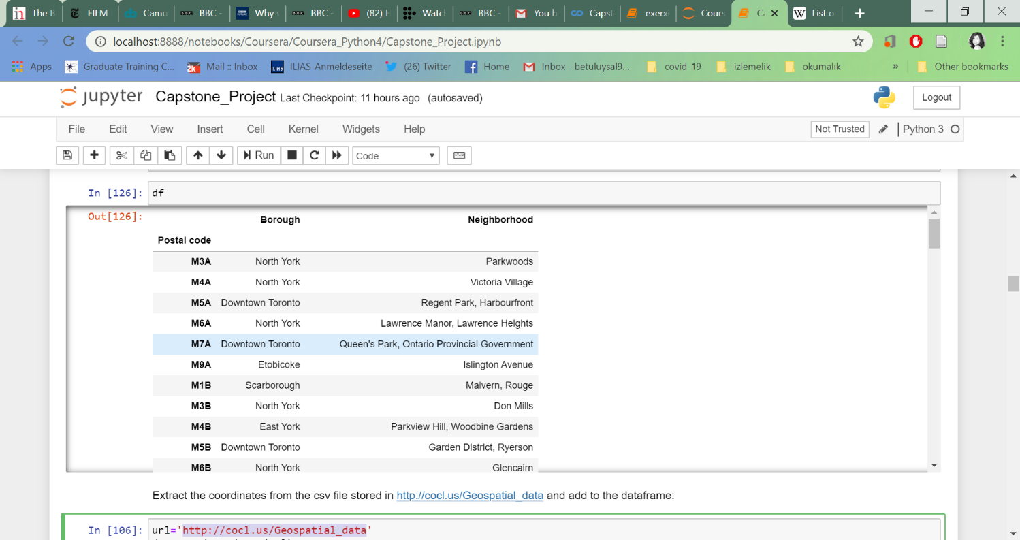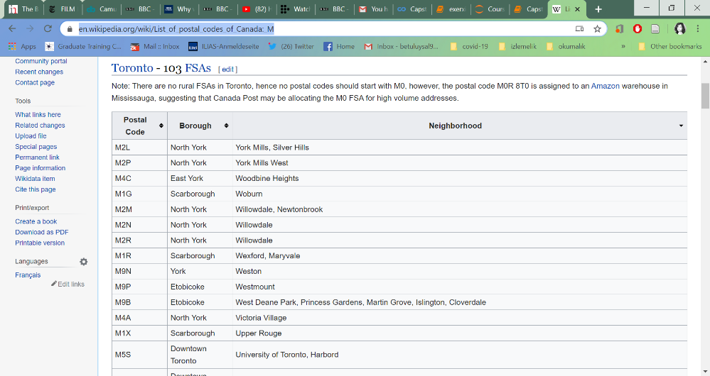

🡪

As I need location information regarding each neighborhood to be able to call all the venues in those neighbourhoods from Foursquare, location info was obtained and loaded into the dataframe.

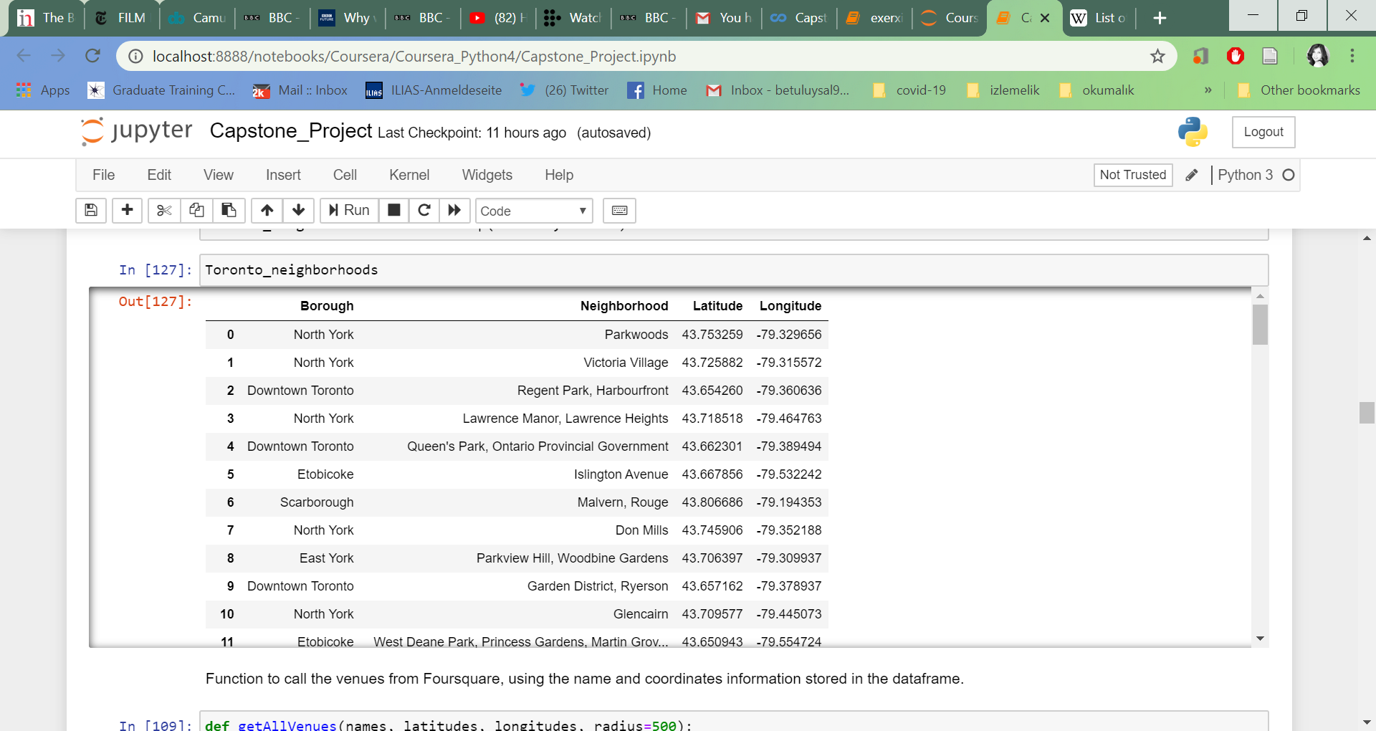

Using my Foursquare ID and secret credentials, I extracted the data regarding venues in Toronto and stored the data in a new dataframe.

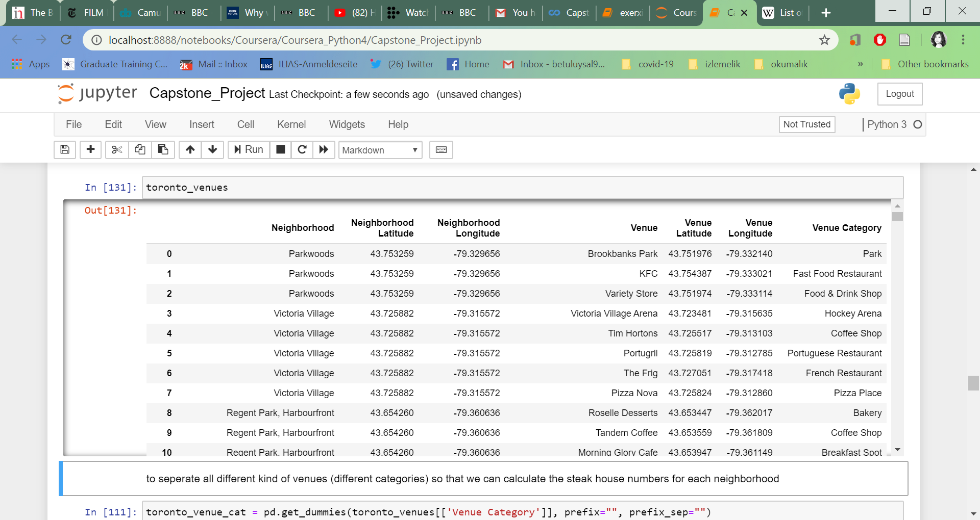

As the new dataframe included venue category together with many other details regarding the venues, I grouped the venues based on their categories.

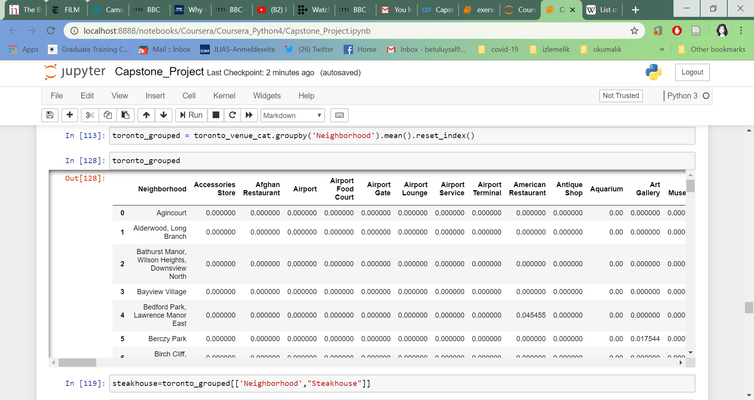

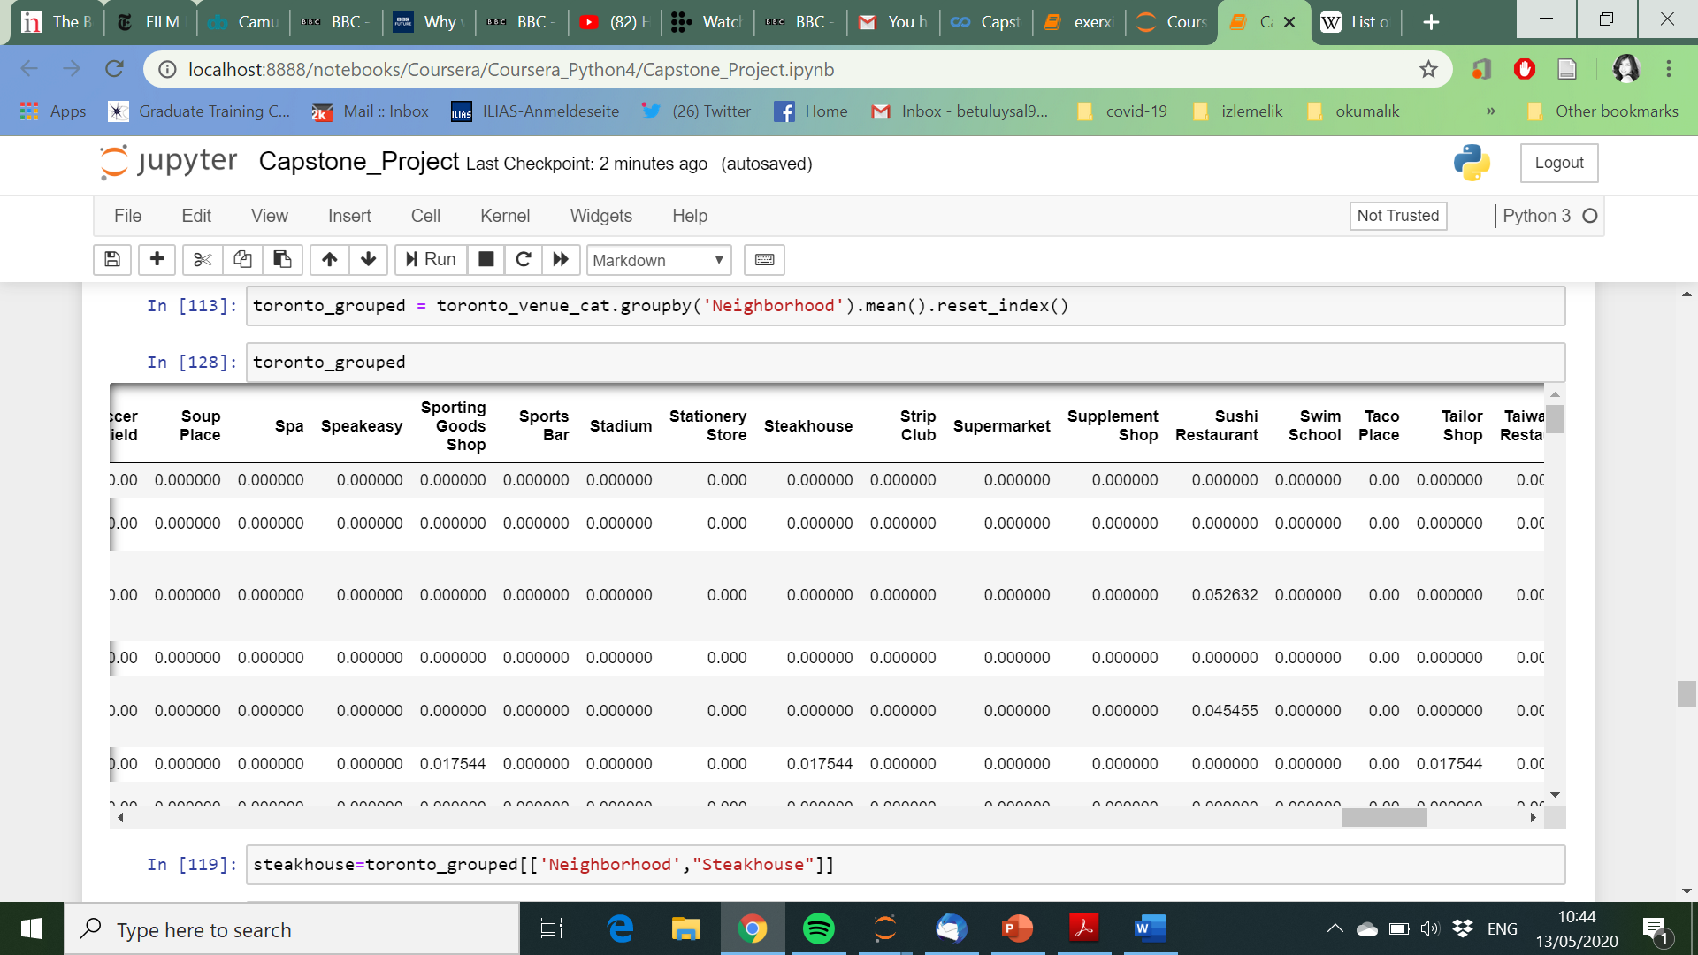

Grouping the venues allowed me to isolate the steakhouses only.

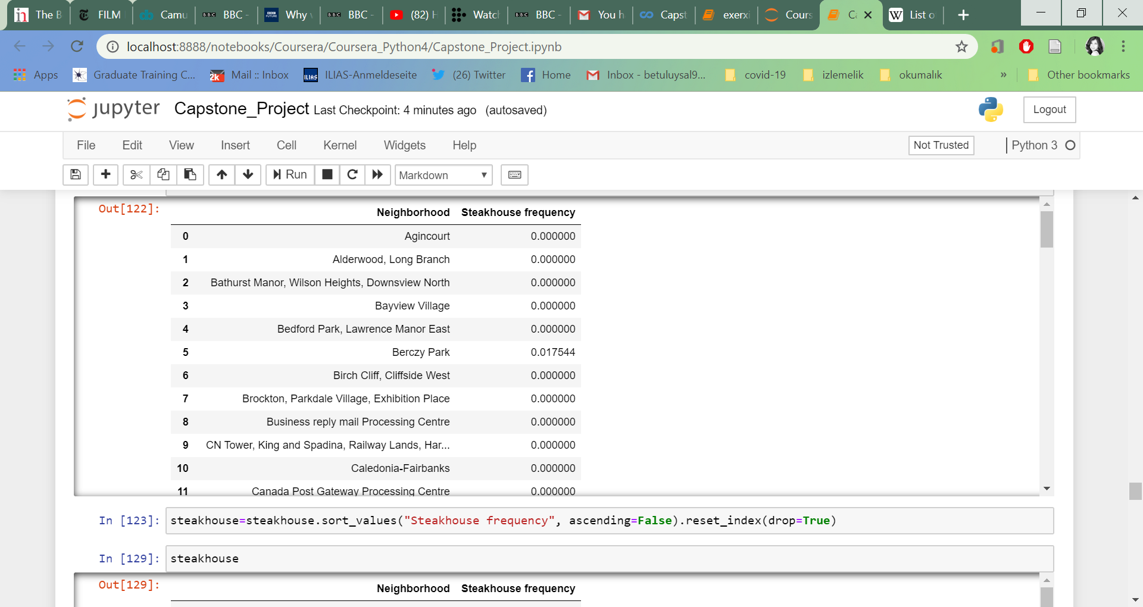

As my initial aim was to see which neighborhoods already have steakhouses and with which frequency I sorted the list in an descending order.

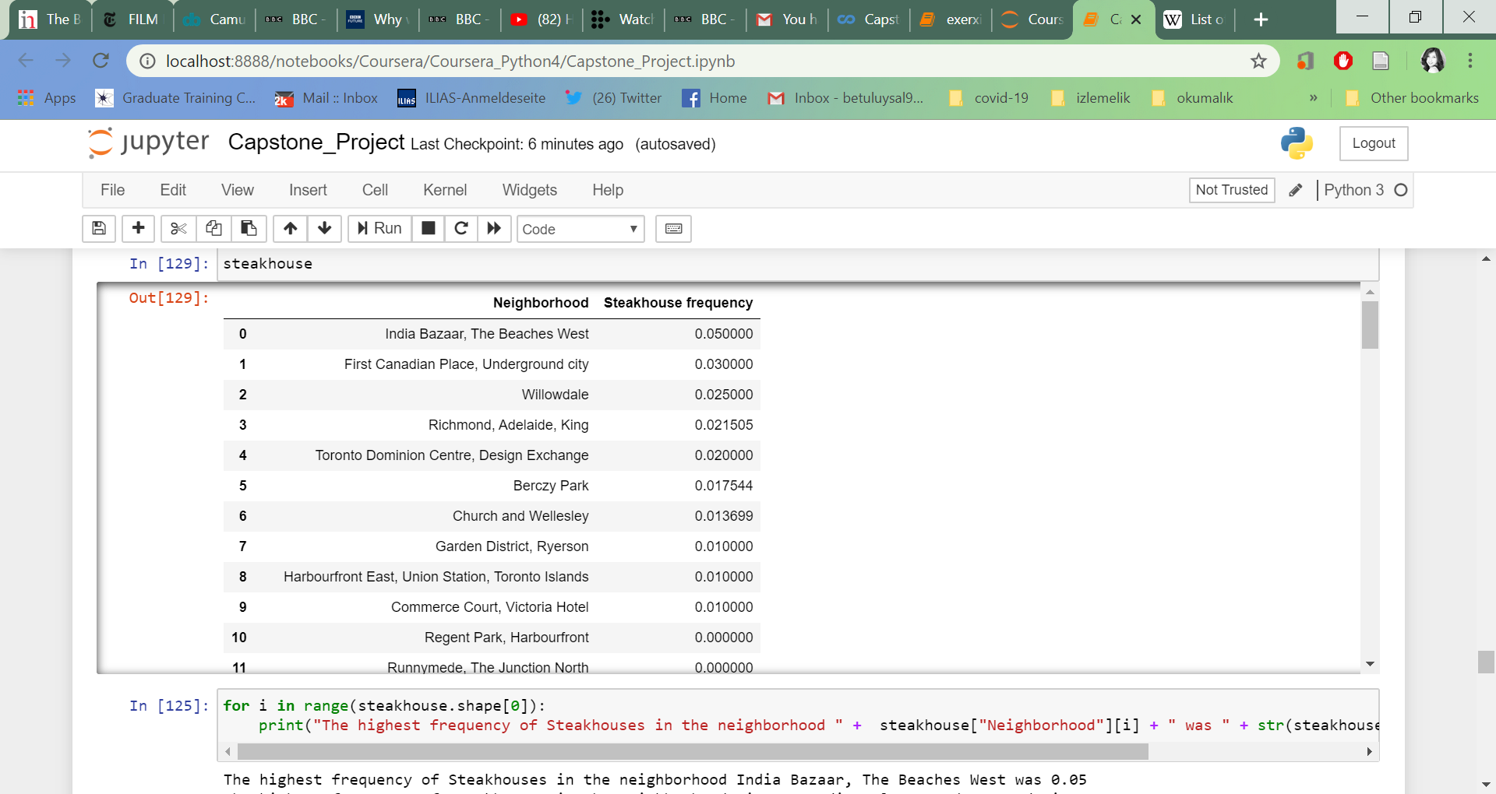

**Results and Discussion**

Here in this project the number of steakhouse restaurants in every neighborhood of Toronto were investigated to be able to provide a steakhouse chain owner with the information regarding where the steakhouses are mostly populated so that he can make a decision for where he thinks that his restaurant would be visited the most. After the data extraction from Foursquare database, using location information obtained for each neighborhood in Toronto, all different kind of venues in these neighborhoods were listed and steakhouse restaurants were isolated from these data. It was found that the neighborhoods that already have steakhouse restaurants, in descending order of frequency, were India Bazaar, The Beaches West, First Canadian Place, Underground, Willowdale, Richmond, Adelaide, King was, Toronto Dominion Centre, Design Exchange, Berczy Park, Church and Wellesley, Garden District, Ryerson, Harbourfront East, Union Station, Toronto Islands, Commerce Court, Victoria Hotel.

Our results showed that some neighborhoods have zero number of steakhouses, which was surprising in the beginning. Nevertheless, steakhouses are usually located in areas where people go out for dinner or so, and not in neighrborhoods where there are mainly housings and not more. Thats why it is understandable that some neighborhoods do not have any steakhouses, and it would still not make sense to open a new one in these regions.

**Counclusion**

Based on these results, opening a restaurant in India Bazaar that has the highest frequency would not make sense nevertheless, Commer court for example, with a low number of steakhouses may be a good choice to open a steakhouse restaurant.